Grind 75
Week 1
1. Two Sum
Hash Map, Arrays
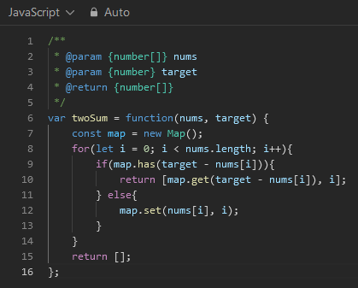

Week 2
1. First Bad Version
Binary Search
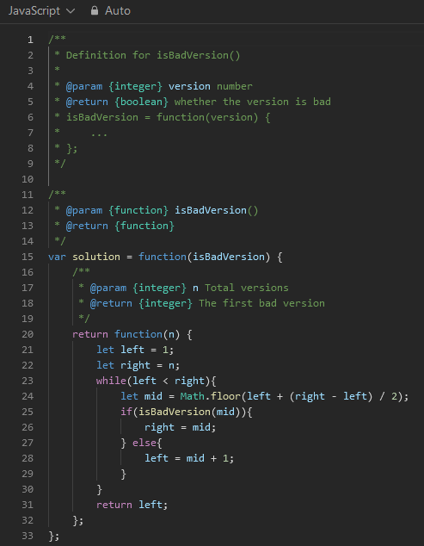

Must use Math.floor with JS to prevent a float from being selected as a version.
If the version at mid is bad, we must check all versions before it.
If the version at mid is not bad, we can check all versions after that version.
Eventually the mid version will be bad and equal to the left pointer because we are using floor division, causing right pointer to be set to mid which is also the left pointer (left = right)breaking the loop. Return left.

General Notes
Averages: use left + ((right-left)/2) to avoid overflow with extremely large numbers.
For example if either left or right is MAX_INT then performing left + right with result in a number greater than MAX_INT causing an overflow error.
-Calculation example [5,28] find average
28+5 / 2 = 16.5
28-5 = 23 / 2 = 11.5 + 5 = 16.5

Maps (JS): Holds key-value pairs.
Keys can be any value including function, object, or other primitives.
-Construction:
const myMap = new Map(); or
new Map([1, "one"], [2, "eggs"], [3, "cheese"]);
-Methods:
Map.set(key, value) - adds or updates and entry with a specified key and value

Test
Maps (JS): Holds key-value pairs.
Keys can be any value including function, object, or other primitives.
-Construction:
const myMap = new Map(); or
new Map([1, "one"], [2, "eggs"], [3, "cheese"]);
-Methods:
Map.set(key, value) - adds or updates and entry with a specified key and value

Test

